Survey Analysis

Radiotherapy

Table of Contents

###### Report Information

|  |  |
| --- | --- |
| Prepared for | International Atomic Energy Agency |
| Prepared by | Julian King, Kate McKegg, Andres Arau, Aaron Schiff, Martina Garcia Aisa |
| Cover image |  |
| Citation | King,J., McKegg, K., Arau, A., Schiff, A., Garcia Aisa, M. (2021). *Social and Economic Impact Assessment of the RCA Programme: Radiotherapy Case Study.* Vienna, Austria: International Atomic Energy Agency. |

## Disclaimer

The information in this document is presented in good faith using the information available to us at the time of preparation. It is provided on the basis that the authors of the document are not liable to any person or organisation for any damage or loss which may occur in relation to taking or not taking action in respect of any information or advice within this document

## Acknowledgements

The authors are grateful for the close and effective assistance of the Technical Cooperation division for Asia-Pacific (TCAP) and Technical Cooperation Division of Programme Support and Coordination (TCPC) of the International Atomic Energy Agency (IAEA), and the experts from the 22 participating countries in the the Radiotherapy Regional Cooperative Agreement (RCA): Australia, Bangladesh, Cambodia, China, Fiji, India, Indonesia, Japan, Laos, Malaysia, Mongolia, Myanmar, Nepal, New Zealand, Pakistan, Palau, Philippines, Singapore, South Korea, Sri Lanka, Thailand, and Viet Nam

# Acronyms

|  |  |
| --- | --- |
| Name | Acronym |
|  |  |
|  |  |
| Government Party | GP |
| International Atomic Energy Agency | IAEA |

# Main findings

# Introduction

This report presents the findings of the Social and Economic Impact Assessment of Radiotherapy (RT) of the RCA in Asia and the Pacific. The data that informs the analysis was collected through an online survey that was designed and piloted in May 2021 and deployed between June and August 2021. The respondents to the survey were national experts on the field of NDT. They provided relevant information about the equipment, training centres, certified personnel, and the health and safety impacts of the RCA programme in their country.

From the 22 countries that are part of the Cooperative Agreement for Research (RCA), 21 participated in the survey: Australia, Bangladesh, Cambodia, China, India, Indonesia, Japan, Laos, Malaysia, Mongolia, Myanmar, Nepal, New Zealand, Pakistan, Palau, Philippines, Singapore, South Korea, Sri Lanka, Thailand, and Vietnam.

Figure: 1 below shows the countries that participated in this study

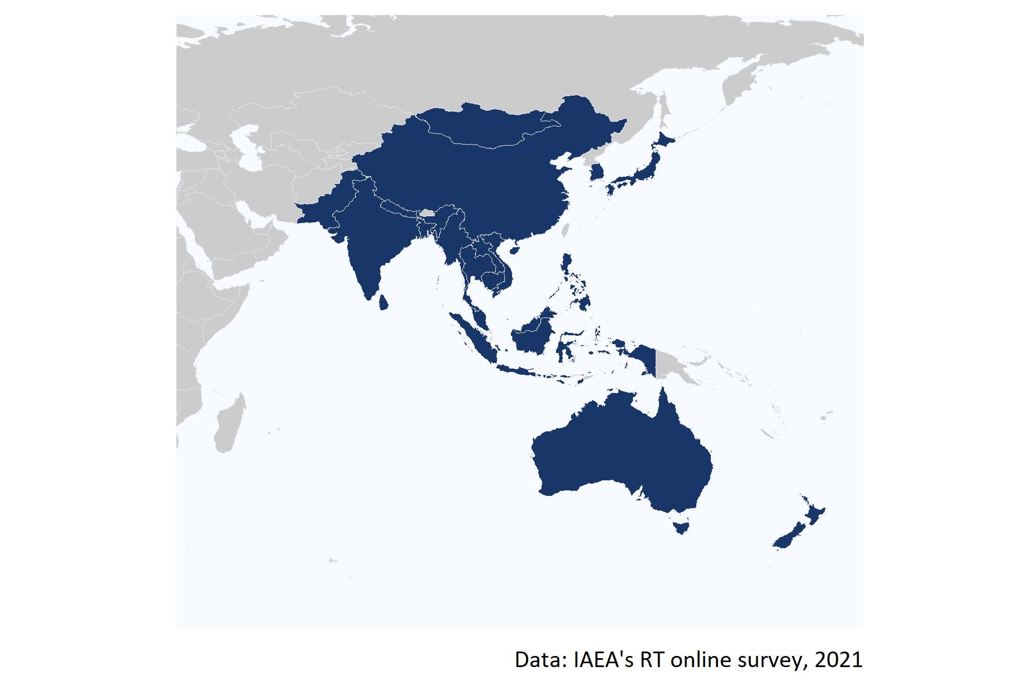

Figure 1: Map of the 20 countries that participated in the online survey.

**Strengthened radiotherapy workforce**

1. Achieve self-reliance in RT, including offering educational training programmes, and establishing Radio Oncology (RO) Departments and Societies.
2. Establish GP’s infrastructure to produce RT specialists in Radiation Oncology, Radiation Oncologists, Medical Physicists, Radiation Technology Therapists, and Radiation Oncology Nurses.

It is worth mentioning that the IAEA Technical Co-operation Programme (TCP) has been established by the IAEA to support IAEA Member States (MSs) (especially developing countries) to accelerate and enlarge the application of nuclear technologies in a safe, secure, effective, and efficient manner. In principle, every IAEA MS can receive and enjoy the benefit of the IAEA TCP. However, some MSs (especially developed/advanced MSs) volunteer not to receive the IAEA TCP, but they work as resource countries to provide support for the IAEA TCP. Under the RCA, there are 22 countries, of which 18 countries are TC recipients and 4 are TC non-recipients (Australia, Japan, New Zealand, and very recently Korea). **Based on this definition, the three countries that have historically acted as non-recipients (Australia, Japan and New Zealand) are excluded from the assessment of the criteria and level of performance conducted in this analysis. Given their historically non-recipient character, any assessment of the performance of RCA to accelerate and enlarge the application of NDT technologies in those countries would result in a misinterpretation of the results.**

# Criterion 1: Strengthened radiotherapy workforce

**Strengthened radiotherapy workforce**

1. Achieve self-reliance in RT, including offering educational training programmes, and establishing Radio Oncology (RO) Departments and Societies.
2. Establish GP’s infrastructure to produce RT specialists in Radiation Oncology, Radiation Oncologists, Medical Physicists, Radiation Technology Therapists, and Radiation Oncology Nurses.

## Criterion 1.1 Achieve self-reliance in RT

### Contribution of the RT RCA in Achieve self-reliance in RT

To have an approximation of the self-reliance in RT of each GP to strength its radiotherapy workforce, the number of educational/training programmes on RT, Radiation Oncology (RO) Departments, and RO Societies that are available in country was estimated.

As can be seen in Figure 2, **there are a total of 116 educational programmes on RT available across all the GPs that are part of the RCA programme**. Vietnam and China are the countries where more programmes (20) are on RT are available, followed by South Korea and Japan where 15 and 10 educational programmes are available.

According to the responses of the GPS, there are none training programmes available in Cambodia, Laos, Palau, and Sri Lanka.

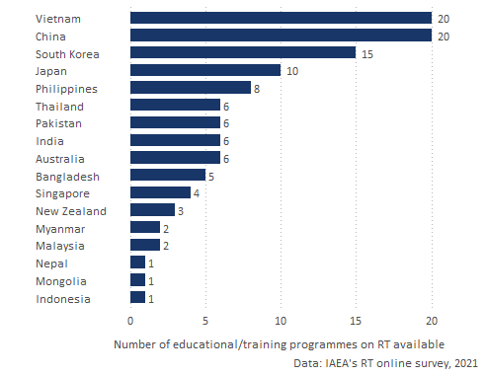

Figure 2: Number of educational or training programmes on RT available by GP.

Moreover, **there a total of 3,215 Radiation Oncology (RO) Departments across all the GPs**. From all those departments 45.5% are located in China, 22.9% in Japan, and in India. Figure 3 shows the number of RO Deparments available in each GP.

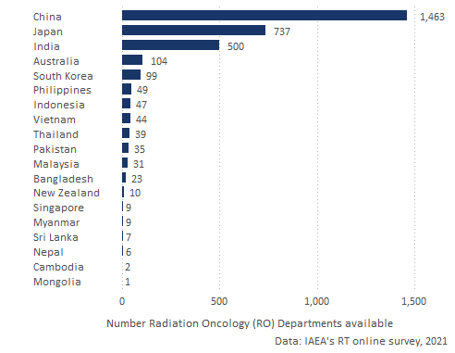

Figure 3: Number of educational or training programmes on RT available by GP.

Figure 4 shows the number of national and regional RO societies estanlished accross the GPs.

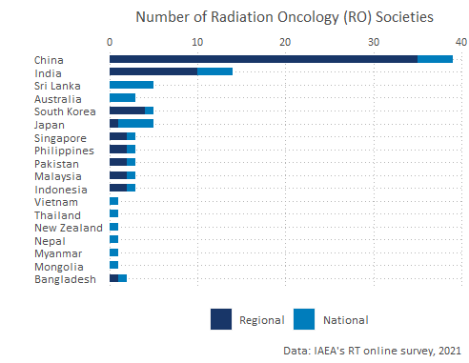

Figure 4: Number of Radiation Oncology (RO) Societies available by type and by GP.

* Total number Radiation Oncology (RO) Societies by regional/national (stacked) *soc_num*
* contribution of RCA in the establishment of the above

*train_cont dep_cont soc_cont*

### Performance standards of Educational programmes

* **Adequate**: RCA contributed to the GPs has at least one of the EP, RO dep, NS
* **Good**: the GPs has two of the EP, RO dep, NS
* **Excellent** : the GPs all of the EP, RO dep, NS

## 1.2 Establish GP’s infrastructure to produce RT specialists

## Contribution of the RCA in certified personnel

* Number of RT specialist by year (dodged) and by field (facet) *roster spec2000 tot_2000 and roster spec2020 tot_2020**
* % of certified : another chart with % certified by year (dodged) and by field (facet) (?) - *cert_2000/tot_2000 and cert_2020/tot_2020*
* extent did the RCA RT programme contribute to the increase of certified RT specialists between 2000 and 2020 *spec_cont*
* Adequate: Any increase in certfied
* Good : Some increase in certified
* Excellent: Significant increased in personnel

train_cont (contribution of RCA on educational programmes) dep_cont (contribution to RO) soc_cont (contribution of societies)

# Criterion 2: Increased access to quality radiotherapy

# Criterion 3: Increased life span and quality of life

# Overall impact of the RT RCA programme

# Annex A: Criteria and standards

|  |  |
| --- | --- |
| **Standard applied to each GP** | **Criterion 1: Improved NDT capacity and capability** |
| **Excellent** (exceeding expectations)    GPs with excellent status meet the standard for Good, plus: | **GPs have fulfilled the MRA requirements of ICNDT** as a result of the support under the RCA programme of IAEA.   * NDT Society is registered with APFNDT and ICNDT * The society is a signatory to ICNDT MRA * NCB for NDT accredited to ISO 17024 * NCB accepted for registration under the ICNDT MRA * Accredited training centres offering ISO 9712 training.   The support in establishing GPs’ NDT infrastructure through the RCA programme has enabled **GPs to produce *certified personnel in advanced techniques (RT-D, PAUT, TOFD, PEC, etc)*, in addition to the conventional methods (RT, UT, MT, PT, ET).**  GPs have achieved increased self-reliance in NDT, including offering training and inspection activities to local industries as well as abroad. |
| **Good** (meeting expectations)  GPs with good status meet the standard for Adequate, plus: | **GPs have established internationally-recognised NDT infrastructure at the national leve**l as a result of the support under the RCA programme of IAEA.   * NDT Society has been established * National certification body on NDT has been established. * Local NDT training centres are offering ISO 9712 training   The support in establishing GPs’ NDT infrastructure through the RCA programme has enabled **GPs to produce certified personnel in all levels of NDTs’ *five main methods* (RT, UT, MT, PT, ET)** through the national NDT certification scheme.[^Since most national certification schemes started late compared to other certification, acceptance is the main challenge.]  GPs have local NDT training centres and inspection companies offering services to local industry. |
| **Adequate** (meeting bottom-line expectations) | GPs have established **basic NDT infrastructure at the national level** as a result of the support under the RCA programme of IAEA.  National certification scheme has been established and there are **certified personnel produced by the national NDT certification scheme, however, for limited method(s) and not for all 5 main methods.**  There are trained personnel at the GP organisation level.  GPs have training centres and inspection companies, owned by foreign entities. |
| **Inadequate** | The level of NDT infrastructure is below the standard for Adequate |

|  |  |
| --- | --- |
| **Standard applied to each GP** | **Criterion 2: Increased scope and scale of NDT demand and use** |
| **Excellent** (exceeding expectations)  GPs with excellent status meet the standard for Good, plus: | From the involvement in the RCA programme, **GPs have managed to support the utilisation of the technology by industry and disseminate the knowledge developed through R&D** by publishing research articles, organising international and national seminars and conferences.  **Participation in the RCA programme results in GPs applying NDT technology in the industrial sectors for the QA and QC of industrial components** - achieving better controlled manufacturing, lower production costs, ensuring material quality, and/or greater product integrity. |
| **Good** (meeting expectations)  GPs with good status meet the standard for Adequate, plus: | From the involvement in the RCA programme, **GPs have successfully applied the NDT technology to local industry, and established R&D activities**.  **Participation in the RCA programme results in GPs becoming more concerned and interested, and starting to apply NDT technology** in the industrial sectors for the QA and QC of industrial components. |
| **Adequate** (meeting bottom-line expectations) | From the involvement in the RCA programme, **GPs have successfully managed to train personnel in the introduced technology**.  **Participation in the RCA programme of IAEA results in GPs initiating activities to create awareness** among industrial organisations about the benefits of NDT technology for QA and QC. |
| **Inadequate** | Any of the standards for Adequate are not met. |

|  |  |
| --- | --- |
| **Standard applied to each GP** | **Criterion 3: Improved health and safety** |
| **Excellent** (exceeding expectations)  GPs with excellent status meet the standard for Good, plus: | As a result of participation in the RCA program of IAEA, **GPs have been applying NDT technology** in the industrial sectors as set by countries’ industrial laws for the QA and QC of industrial components - **resulting in  improved health and safety outcomes** (i.e. fewer deaths and injuries) and/or reduced environmental pollution. |
| **Good** (meeting expectations)  GPs with good status meet the standard for Adequate, plus: | Participation in the RCA program of IAEA results in **GPs applying NDT technology for safer operation** of nuclear and other industrial installations. |
| **Adequate** (meeting bottom-line expectations) | Participation in the RCA program of IAEA results in **GPs becoming more aware of the benefits of NDT technology for safer operation** of nuclear and other industrial installations. |
| **Inadequate** | Any of the standards for Adequate are not met. |